2.8 UIKit Survey

- Label is small piece of text for example general
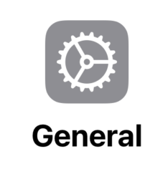
- Image view displays an image or icon

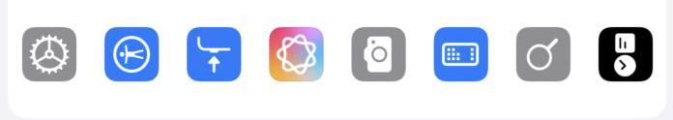

- Text View display editable or non editable text for example the text under apple account

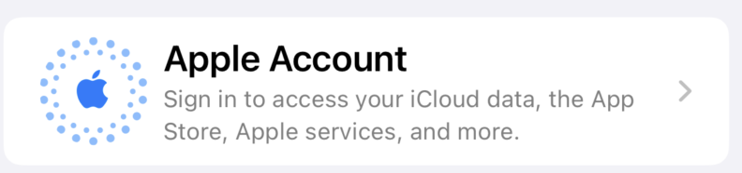

- Table view: a list of cells in apps like Setting

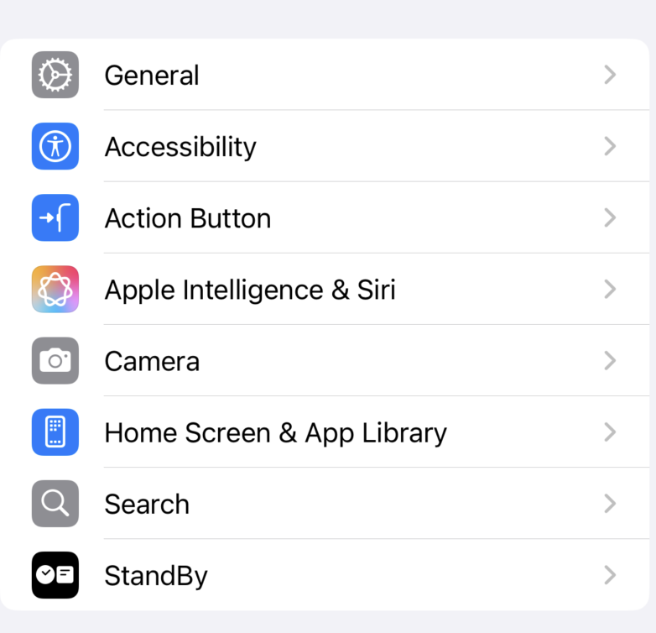

- Navigation bar: a bar at the top that shows the title and navigation buttons

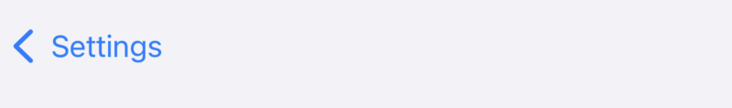

- Tab Bar: a bar at the bottom used to switch between sections

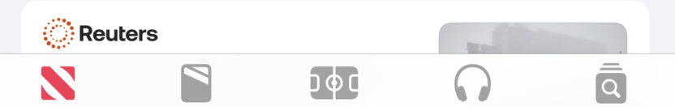
- Button: a tappable control that performs an action for example + button



- Segmented control: Horizontal group of segments used to choose options

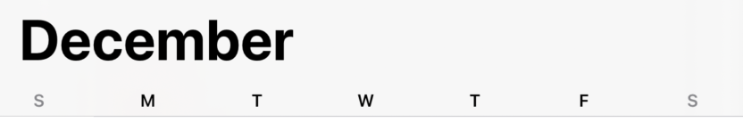

- Text Field: text input

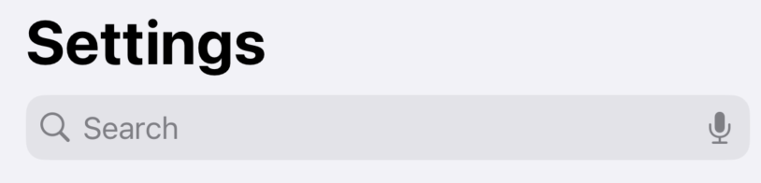

- Switch: a toggle that turns ON and OFF

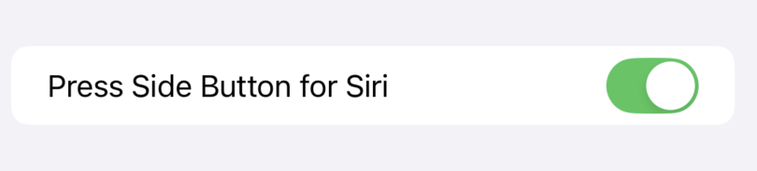

- A control that selects a value along a range

